Airline Ticket Price Analysis
Abstract
Airline ticket price analysis helps explain how airfare changes under different travel and booking conditions, and why passengers often find large price differences even for similar journeys. Ticket prices in the airline industry are influenced by several factors, including the airline operating the route, travel distance, class of service, and the number of days remaining before departure. In many cases, prices increase as departure dates approach, while premium travel classes and high-demand routes often show consistently higher fare levels. Understanding these pricing patterns is important because it reveals how airlines manage fare structures across routes and how travel choices affect passenger cost. This project studies airline ticket pricing by examining airline name, origin, destination, distance, travel class,
booking time before departure, and ticket price to understand how these factors are connected. This analysis helps compare fare variation across airlines, identify routes with higher pricing, and explain differences between economy and premium travel classes. It also provides insight into how advance booking influences ticket cost and where pricing differences become more noticeable across travel conditions. The study presents a broader understanding of airfare behaviour and highlights the key pricing patterns that shape airline fare decisions across different travel situations.

2. INTRODUCTION
The airline industry is a complex and highly competitive domain where pricing strategies play a crucial role in determining both profitability for airlines and affordability for passengers. Airline ticket prices are not fixed and often vary significantly based on multiple factors such as travel distance, route demand, airline brand, class of service, and the time of booking. This dynamic pricing system is designed to maximize revenue while adjusting to changing market conditions. As a result, passengers frequently observe large price differences for similar journeys, making it important to understand how these variations occur and what factors influence them.
In today’s data-driven environment, analyzing such variations has become essential for both businesses and consumers. For airlines, understanding pricing patterns helps in optimizing revenue management strategies and improving competitive positioning. For passengers, data analysis provides insights into when and how to book tickets at lower prices. By examining structured datasets that include variables like airline name, source and destination locations, distance traveled, travel class, booking time, and ticket price, meaningful patterns can be identified that explain pricing behavior across different scenarios.
The importance of analyzing data in this context lies in its ability to transform raw information into actionable insights. Instead of relying on assumptions or limited observations, data analysis allows for a systematic study of trends and relationships. For example, it becomes possible to identify whether ticket prices consistently increase as the departure date approaches, or how significantly premium classes differ in cost compared to economy class. Such insights not only enhance understanding but also support better decision-making for both airlines and travelers.
Data analytics plays a vital role in solving real-world problems by uncovering hidden patterns and relationships within large datasets. In this project, tools such as Pandas and NumPy are used for data cleaning and manipulation, while Matplotlib helps in visualizing pricing trends. Additionally, SQL in MySQL is used to perform structured queries that extract meaningful information from the dataset. Through these techniques, the project demonstrates how analytical methods can be applied to understand airline ticket pricing, identify key influencing factors, and provide a clear interpretation of how different variables contribute to fare variations.
Overall, this analysis highlights the practical application of data analytics in the airline domain and shows how structured data processing and querying can lead to a deeper understanding of pricing behavior, ultimately helping in both business optimization and informed travel planning.

3. EXISTING SYSTEM
In the existing system, airline ticket data is primarily stored in Excel files in a tabular format. Each record contains details such as airline name, origin, destination, distance, class, booking time, and ticket price. Excel is used as a basic tool to organize and maintain this data, making it easy to store and access information in rows and columns.
The data entry process in this system is mostly manual, where users input values directly into the Excel sheets. This approach increases the chances of human errors such as incorrect entries, missing values, or inconsistencies in data formatting. Since there are no automated validation or processing mechanisms, maintaining data accuracy becomes a challenge, especially as the dataset grows larger.
The primary use of this system is limited to viewing and basic handling of records. While Excel provides simple features like sorting and filtering, it does not support advanced data analysis or complex querying efficiently. As a result, extracting meaningful insights, identifying patterns, and performing detailed analysis of airline ticket pricing becomes difficult and time-consuming in the existing system.

4. DISADVANTAGES OF EXISTING SYSTEM
- Human errors are common because data is entered manually, which can lead to incorrect values, missing information, and inconsistent formatting across records.
- The process is time-consuming as updating, verifying, and organizing data in Excel requires continuous manual effort, especially when the dataset grows.
- There is no proper analysis capability since Excel is mainly used for storing and viewing data, making it difficult to perform complex queries or extract meaningful insights.
- Managing large volumes of data becomes difficult because Excel files can become slow, unorganized, and hard to maintain when the number of records increases significantly.

5. PROPOSED SYSTEM
The proposed system improves the overall data analysis process by transforming raw airline ticket data into a structured and enriched format that supports efficient querying and deeper insights. Initially, data is collected in Excel or CSV format, which contains basic fields such as airline name, origin, destination, distance, class, booking time, and ticket price. This raw data is then cleaned and enhanced by adding new derived attributes such as route, booking type, distance category, price category, premium class indicator, and price per kilometer. These additional fields help in simplifying analysis and improving clarity in understanding pricing patterns.
After preprocessing, the structured dataset is imported into a MySQL database, where it is stored in well-defined tables. SQL plays a key role at this stage by enabling efficient querying of the data. Using SQL queries, specific insights can be extracted, such as identifying which routes have higher ticket prices, comparing fare differences across booking types like early and late booking, and analyzing how distance categories affect pricing. SQL operations like filtering, grouping, aggregation, and sorting allow quick and accurate retrieval of relevant data without manual effort.
Once the required data is extracted from the database, Python is used for further processing and analysis in a Jupyter Notebook environment. Libraries such as Pandas and NumPy help in handling data transformations, performing calculations, and preparing the dataset for analysis. For example, Python can be used to compute average prices across different categories, identify trends in booking behavior, and handle any remaining inconsistencies in the data. Matplotlib is then used to visualize these results, making it easier to observe patterns such as how price varies with distance or how premium classes differ from standard classes.
The final output of the system includes well-structured result tables and graphical representations that clearly explain airline ticket pricing behavior. By combining SQL for efficient data retrieval and Python for advanced processing and visualization, the proposed system provides a complete and effective solution for analyzing airline ticket price variations across multiple factors.

6. ADVANTAGES OF PROPOSED SYSTEM
- Faster analysis is one of the major advantages of the proposed system because data is stored in a structured MySQL database instead of unorganized Excel files. SQL queries allow users to retrieve required information within seconds, even when working with large datasets. This eliminates the need for manual searching, sorting, and filtering, thereby significantly reducing the time required to perform analysis. As a result, users can focus more on interpreting results rather than spending time on data handling.
- Accurate results are achieved as the system minimizes human intervention in data processing. Since calculations and data manipulations are performed using SQL queries and Python libraries such as Pandas and NumPy, the chances of errors are greatly reduced. The use of structured queries ensures consistency in outputs, and repeated analysis can be performed with the same level of accuracy. This reliability is important for drawing correct conclusions from airline ticket pricing data.
- Organized data management is another key advantage of the proposed system. Data is stored in well-defined tables with clearly structured columns, including both original attributes and newly derived fields such as route, booking type, and price category. This organization makes it easier to maintain, update, and retrieve data without confusion. Even as the dataset grows, the system remains manageable and efficient, unlike Excel-based systems which become cluttered over time.
- Easy query-based insights are possible because SQL provides powerful operations such as filtering, grouping, aggregation, and sorting. Users can easily write queries to answer specific questions, such as identifying the most expensive routes, comparing ticket prices across different classes, or analyzing the impact of booking time on pricing. These insights can be obtained quickly and accurately without manual calculations. This capability makes the system highly effective for understanding patterns and trends in airline ticket pricing.

7. INTRODUCTION TO APPLICATION
The application is designed to analyze airline ticket pricing data by transforming raw datasets into meaningful insights using SQL and Python-based processing. It takes structured data containing details such as airline name, route, distance, travel class, booking time, and ticket price, and processes it to understand how these factors influence airfare. The system not only stores and organizes the data efficiently but also enables detailed analysis to identify pricing patterns, variations across routes, and differences between travel classes. By integrating database querying and analytical processing, the application provides a complete solution for studying airline ticket price behavior.
User interaction with the system is primarily based on query execution and result interpretation. The user interacts with the MySQL database by writing SQL queries to retrieve specific information from the dataset. For example, a user can query average ticket prices for different airlines, compare early booking versus late booking prices, or identify routes with the highest fares. Once the data is extracted using SQL, it is passed into a Python environment where further processing and analysis are performed. The user can then view the results in the form of structured tables and visual representations, making it easier to understand patterns and trends.
The data flow in the application follows a systematic and logical sequence. Initially, data is collected in Excel or CSV format and then cleaned and transformed using Python to ensure consistency and accuracy. This processed data is then loaded into a MySQL database, where it is stored in structured tables. SQL queries are applied to extract relevant subsets of data based on analytical requirements. The queried data is then sent to Python for further processing, calculations, and visualization using tools like Pandas, NumPy, and Matplotlib. Finally, the results are generated in the form of tables and graphs that clearly present insights into airline ticket pricing. This smooth flow of data ensures efficiency, accuracy, and clarity throughout the analysis process.

8. BLOCK DIAGRAM
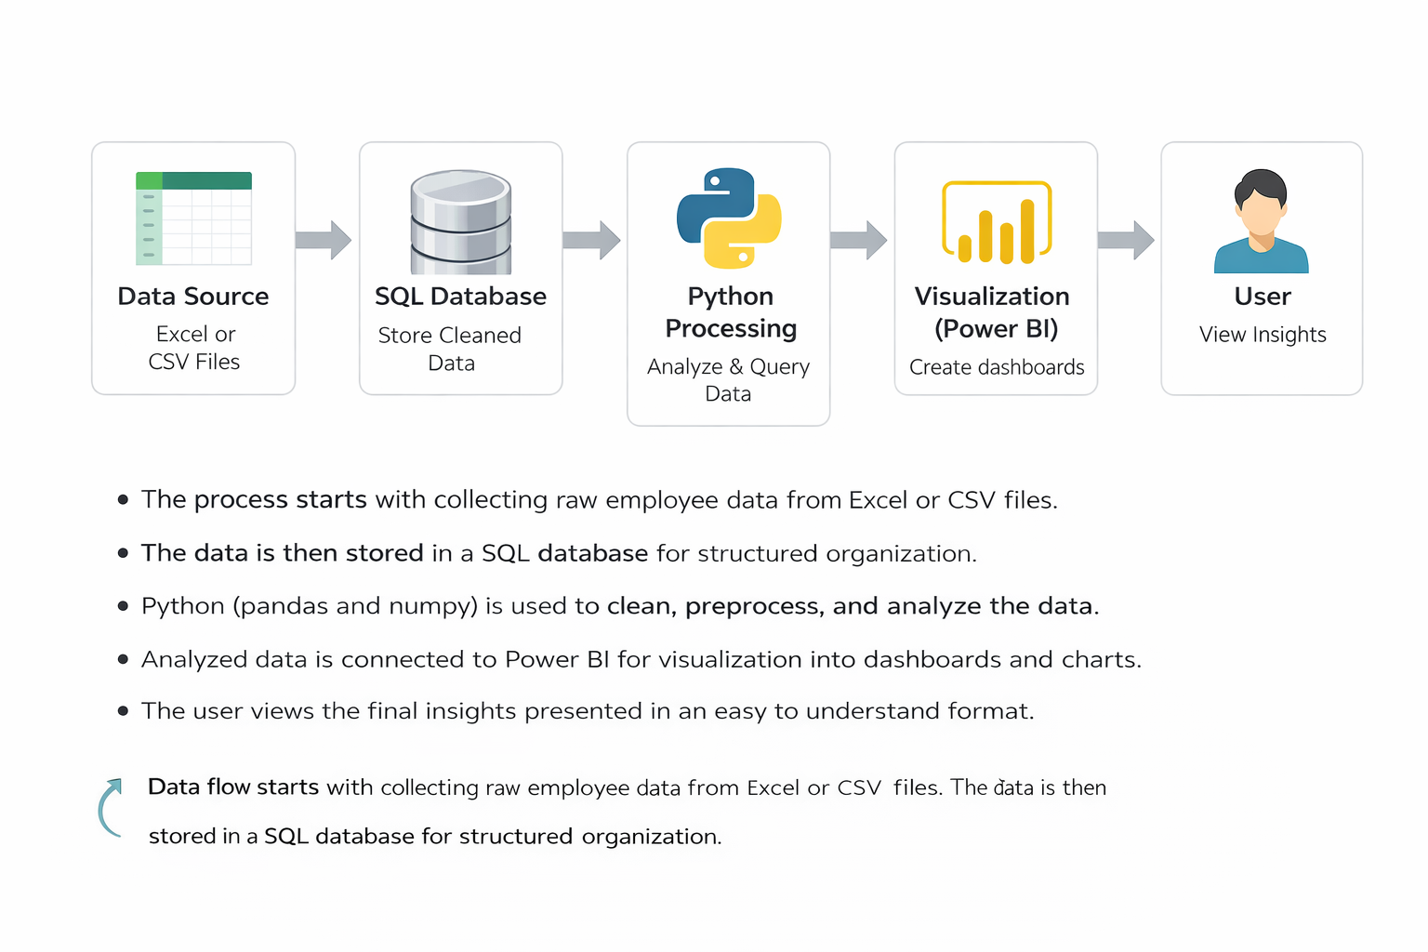

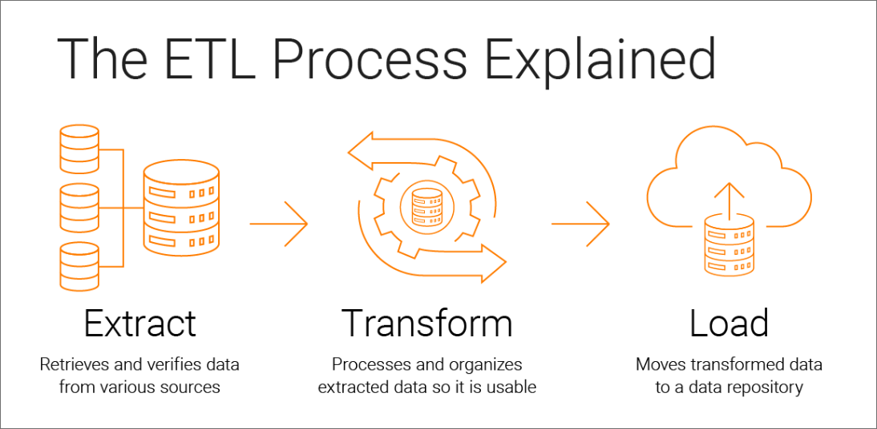

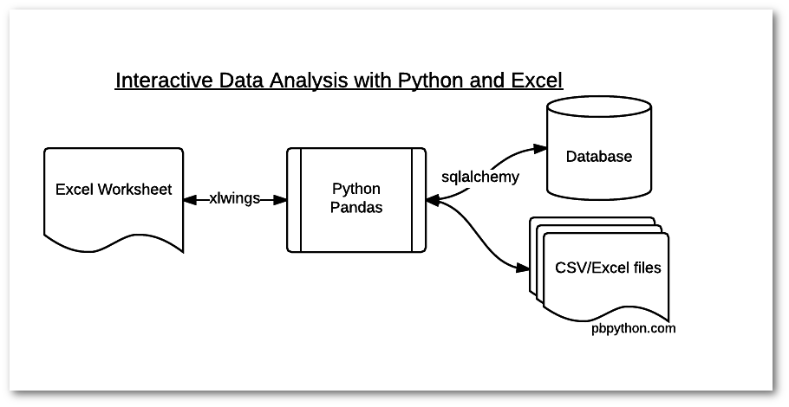
The block diagram represents the overall flow of data in the system, showing how raw data is transformed into meaningful insights through different stages of processing. The system follows a simple and logical structure starting from the data source and ending with the user.
The Data Source block represents the initial stage where airline ticket data is collected. This data is typically stored in Excel or CSV files and contains raw information such as airline name, origin, destination, distance, travel class, booking time, and ticket price. At this stage, the data may not be fully structured or ready for analysis.
The SQL Database block is responsible for storing the data in a structured format. After cleaning and preparing the data, it is loaded into a MySQL database where it is organized into tables. SQL is used to manage the data and perform operations such as filtering, grouping, and aggregation. This block ensures efficient storage and quick retrieval of data for analysis.
The Python Processing block handles further data analysis and transformation. The data retrieved from the SQL database is processed using Python libraries such as Pandas and NumPy. This stage includes data manipulation, calculations, and preparation for visualization. Matplotlib is used to generate graphs and charts that help in understanding patterns and trends in ticket pricing.
The User block represents the final stage where results are presented. The user interacts with the system by running SQL queries and viewing the processed outputs. The results are displayed in the form of tables and visualizations, allowing the user to easily interpret insights and understand airline ticket pricing behavior.

9. DATA ANALYTICS SECTION
9.1 OVERVIEW
The data analytics section focuses on extracting meaningful insights from airline ticket pricing data using structured query techniques and Python-based processing. The primary objective of this section is to analyze how different factors such as airline name, route, distance, travel class, and booking time influence ticket prices. By working with a well-organized dataset, the analysis aims to identify patterns, trends, and relationships that explain variations in airfare across different travel conditions.
The process begins with data preparation, where raw data collected in Excel or CSV format is cleaned and structured using Python libraries such as Pandas and NumPy. This step ensures that missing values, inconsistencies, and formatting issues are handled properly before analysis. Once the data is prepared, it is stored in a MySQL database, enabling efficient querying and structured access to information.
SQL plays a central role in the analytics process by allowing the extraction of relevant data through queries. Using SQL operations such as filtering, grouping, and aggregation, the system can answer important questions like which airline offers higher average ticket prices, how pricing varies across routes, and how booking time affects fare levels. These queries help in narrowing down large datasets into meaningful subsets for further analysis.
After retrieving the required data using SQL, Python is used to perform deeper analysis and visualization. Pandas is used to manipulate data and compute additional metrics, while Matplotlib is used to generate graphs that clearly represent trends and comparisons. This combination of SQL and Python enables both efficient data handling and detailed analytical exploration.
Overall, this section provides a structured approach to analyzing airline ticket pricing data, demonstrating how data analytics techniques can be used to transform raw data into valuable insights that explain real-world pricing behavior.

9.2 DATA DESCRIPTION
The dataset used in this project consists of structured information related to airline ticket pricing. Each row in the dataset represents a single ticket record, while each column represents a specific attribute associated with that ticket. The dataset is designed to capture important factors that influence airfare, enabling detailed analysis of pricing behavior across different travel conditions.
The main columns in the dataset include Airline Name, Source, Destination, Distance, Travel Class, Days Left for Departure, and Ticket Price. The Airline Name column stores the name of the airline operating the flight. Source and Destination represent the origin and arrival locations of the journey. Distance indicates the total travel distance between the two locations. Travel Class specifies whether the ticket belongs to economy or premium class. Days Left for Departure shows how many days in advance the ticket was booked. Ticket Price represents the cost of the ticket for that particular record.
Each column is associated with a specific data type based on the nature of the data it stores. Airline Name, Source, Destination, and Travel Class are categorical data types, as they represent labels or categories. Distance and Days Left for Departure are numerical data types, as they represent measurable values. Ticket Price is also a numerical data type, typically stored as a continuous value since it can vary across a wide range.
The purpose of these columns is to provide a comprehensive view of all key factors that influence airline ticket pricing. Airline Name helps in comparing fare differences across different airlines. Source and Destination together define the route, which is useful for analyzing route-based price variations. Distance allows the study of how travel length impacts ticket cost. Travel Class helps differentiate pricing between economy and premium services. Days Left for Departure is crucial for understanding how booking time affects pricing. Ticket Price serves as the primary variable for analysis, as it reflects the final outcome influenced by all other factors.
Overall, this dataset is structured in a way that supports both SQL-based querying and Python-based analysis, making it suitable for identifying trends, patterns, and relationships in airline ticket pricing.

9.3 DATA PREPROCESSING
Data preprocessing is an important step in the analysis process, as it ensures that the dataset is clean, consistent, and ready for accurate analysis. Raw data collected from Excel or CSV files often contains errors, inconsistencies, or incomplete values, which can affect the quality of results if not handled properly. Therefore, preprocessing is performed using Python libraries such as Pandas and NumPy before storing the data in the SQL database.
Cleaning involves identifying and correcting errors present in the dataset. This includes removing duplicate records, correcting incorrect entries, and standardizing values across columns. For example, airline names or city names may appear in different formats, and these inconsistencies are corrected to maintain uniformity. Data cleaning ensures that all records follow a consistent structure, which is essential for accurate querying and analysis.
Handling missing values is another key part of preprocessing. In some cases, certain fields such as distance or ticket price may have missing or null values. These missing values are either filled using appropriate methods such as mean or median substitution, or the affected records are removed if they are not suitable for analysis. Proper handling of missing data ensures that calculations and results are not distorted.
Formatting focuses on converting data into the correct structure and type required for analysis. This includes ensuring that numerical columns such as distance, days left for departure, and ticket price are stored in the correct numeric format, while categorical columns such as airline name and travel class are properly labeled. Date or time-related fields, if present, are also formatted correctly. Proper formatting improves compatibility with SQL queries and Python operations, making the analysis process smooth and efficient.
Overall, data preprocessing enhances the quality and reliability of the dataset, ensuring that subsequent analysis produces meaningful and accurate insights.

9.4 EXPLORATORY DATA ANALYSIS
Exploratory Data Analysis is performed to understand the underlying structure of the dataset and to identify important trends, patterns, and relationships in airline ticket pricing. This stage involves examining the data using statistical summaries and visualizations to gain initial insights before performing detailed analysis. By exploring the data, it becomes easier to understand how different factors influence ticket prices and how these factors interact with each other.
Trends in the dataset reveal how ticket prices change with respect to specific variables. One of the most noticeable trends is the relationship between booking time and ticket price, where prices tend to increase as the number of days left before departure decreases. Another trend can be observed in relation to distance, where longer routes generally show higher ticket prices. Additionally, premium travel classes consistently exhibit higher pricing compared to economy class, indicating a clear difference in fare structure based on service level.
Patterns in the data help in identifying consistent behaviors across different categories. For example, certain airlines may consistently have higher average ticket prices compared to others, reflecting differences in brand positioning or service quality. Route-based patterns may also emerge, where specific source and destination combinations show higher demand and therefore higher prices. Grouping and aggregation using SQL queries further help in identifying such patterns, making it easier to compare categories and understand pricing variations.
Observations derived from the analysis provide meaningful insights into real-world airline pricing behavior. It can be observed that early booking generally results in lower ticket prices, while last-minute bookings tend to be more expensive. Variations in pricing across routes highlight the impact of demand and competition. Differences between travel classes emphasize how service level influences cost. These observations collectively help in explaining why airline ticket prices vary and provide a clear understanding of the factors that drive these variations.
Overall, exploratory data analysis plays a crucial role in uncovering key insights from the dataset, forming the foundation for deeper analysis and interpretation in later stages of the project.

9.5 TOOLS USED
The following tools are used in this project to perform data processing, analysis, storage, and visualization. Each tool plays a specific role in the overall workflow.
1. Python
Python is the core programming tool used for implementing the entire data analysis process. It is used to write scripts for data cleaning, transformation, and analysis.

2. Jupyter Notebook
Jupyter Notebook is used as the development tool where Python code is written and executed. It provides an interactive environment to run code step-by-step and view outputs instantly.

3. Pandas
Pandas is used for data manipulation and handling structured data. It helps in reading datasets, filtering data, grouping values, and creating new columns required for analysis.

4. NumPy
NumPy is used for numerical computations. It supports mathematical operations and helps in handling arrays and performing calculations efficiently.

5. Matplotlib
Matplotlib is used for creating visualizations such as bar charts and histograms. It helps in understanding patterns and trends in the dataset during analysis.

6. MySQL
MySQL is used as the database tool for storing and managing the dataset. It allows execution of SQL queries to retrieve and analyze data efficiently.

10. SOFTWARE REQUIREMENTS
Software requirements refer to the platforms and environments needed to develop, run, and execute the project. These provide the base setup where all tools and libraries function.
1. Operating System
The project can run on operating systems such as Windows, macOS, or Linux. In this project, a Windows environment is typically used, which supports Python, Jupyter Notebook, and other required tools. The operating system manages file handling, software installation, and execution of programs.

2. Python Environment
Python is required as the core programming language. A proper Python environment must be installed to execute scripts and run data analysis.
In this project:
- Python is used to write all preprocessing and analysis logic
- It acts as the base for libraries like pandas, NumPy, and matplotlib
- Version compatibility is important to ensure smooth execution

3. Jupyter Notebook Environment
Jupyter Notebook is required as the development platform for writing and running code interactively.
In this project:
- It provides an interface to execute Python code step-by-step
- It allows combining code, outputs, and explanations in one place
- It helps in testing and debugging during development

4. Library Support (Python Packages)
The system requires installation of essential Python libraries. These are not standalone software but part of the Python environment.
Required libraries include:
- pandas for data handling
- NumPy for numerical operations
- matplotlib for visualization
These libraries must be installed using package managers such as pip before running the project.

5. Database Software (MySQL)
MySQL is used as the database system for storing and querying structured data.
In this project:
- It stores insurance dataset in table format
- SQL queries are executed to filter and analyze data
- It supports structured data management and retrieval

7. Web Browser
A web browser such as Chrome or Edge is required to access Jupyter Notebook and Power BI interfaces. It provides the interface for interacting with dashboards and notebooks.

11. HARDWARE REQUIREMENTS
1. Processor
- Minimum Intel Core i3 or equivalent
- Recommended Intel Core i5 or higher
The processor is responsible for executing all operations in the system. A basic processor like i3 can handle small datasets and simple analysis. However, for better performance, especially when running multiple tools such as Jupyter Notebook and Power BI together, a higher processor like i5 or above is preferred. A faster processor reduces computation time and improves overall system responsiveness.
2. RAM
- Minimum 4 GB RAM
- Recommended 8 GB or more
RAM is used to temporarily store data during execution. A minimum of 4 GB is sufficient for basic tasks, but it may cause slow performance when handling larger datasets. Using 8 GB or more allows smoother multitasking and faster data processing. Higher RAM ensures that the system does not lag when multiple applications are running.
3. Storage
- Minimum 256 GB storage
- Recommended SSD storage
Storage is required to install software and store datasets and project files. A minimum of 256 GB is needed for proper functioning. Solid State Drives are recommended over traditional hard drives because they provide faster data access and improve system speed. Faster storage reduces loading time and enhances performance.
4. Operating System
- Windows, macOS, or Linux supported
- Recommended 64-bit Windows 10 or above
The operating system acts as the base platform for running all tools and applications. A 64-bit system is recommended for better compatibility and performance. Windows 10 or higher is commonly used as it supports all required software such as Python, MySQL, and Power BI efficiently.
Summary
The hardware components play an important role in ensuring smooth execution of the project. A good processor, sufficient RAM, fast storage, and a compatible operating system together provide a stable and efficient working environment.

Why These Hardware Requirements Are Sufficient for the Project
The specified hardware configuration is sufficient for this project because the nature of the work involves moderate data processing, analysis, and visualization, rather than extremely heavy computations or large-scale distributed systems. Each component supports the project requirements effectively.
Processor Sufficiency
The project mainly uses Python, Jupyter Notebook, SQL queries, and Power BI dashboards. These tasks involve data manipulation, filtering, grouping, and visualization, which do not require very high-end processing power. A processor like Intel Core i3 can handle these operations without major issues. However, using an i5 or higher ensures faster execution when performing multiple operations or running several tools at the same time. Since the dataset is of manageable size and not extremely large, this level of processing power is sufficient.
RAM Sufficiency
The dataset used in this project is structured and moderate in size, meaning it can easily fit into memory. A minimum of 4 GB RAM is enough to load and process such data in pandas and NumPy. However, when using tools like Power BI along with Jupyter Notebook, additional memory is beneficial. With 8 GB RAM, the system can handle multitasking smoothly, ensuring that data analysis, visualization, and querying operations run without lag. Therefore, this RAM range is adequate for efficient performance.
Storage Sufficiency
The project requires storage for datasets, software installations, and output files such as reports and dashboards. The data size is not extremely large, so 256 GB storage is more than enough to accommodate all files. Using SSD storage further improves performance by reducing loading times and speeding up file access. This ensures quick opening of datasets, faster execution of notebooks, and smooth operation of Power BI dashboards.
Operating System Sufficiency
The project tools such as Python, Jupyter Notebook, MySQL, and Power BI are fully compatible with modern operating systems like Windows, macOS, and Linux. A 64-bit operating system ensures better memory utilization and supports all required software efficiently. Windows 10 or above is commonly used and provides a stable environment for running all components without compatibility issues. Therefore, the operating system requirement is sufficient for seamless execution.
Overall Justification
The project does not involve heavy machine learning models, real-time big data processing, or high-performance computing tasks. Instead, it focuses on structured data analysis, visualization, and dashboard creation. The specified hardware is capable of handling these operations efficiently without unnecessary resource usage. It provides a balanced configuration that ensures smooth performance, cost-effectiveness, and practical usability for real-world implementation.

12. METHODOLOGY
The methodology of this project follows a systematic step-by-step approach to ensure that airline ticket data is properly collected, processed, analyzed, and interpreted. Each stage in the process is designed to transform raw data into meaningful insights using SQL and Python tools.
The first step is data collection, where airline ticket data is gathered in the form of Excel or CSV files. This data includes important attributes such as airline name, source, destination, distance, travel class, booking time, and ticket price. The collected data serves as the foundation for the entire analysis process.
The next step is data cleaning using Python. In this stage, libraries such as Pandas and NumPy are used to handle inconsistencies in the dataset. This includes removing duplicate records, correcting incorrect values, handling missing data, and ensuring uniform formatting across all columns. Data cleaning is essential to improve the quality and reliability of the dataset before analysis.
After cleaning, the data is stored in a MySQL database. This step involves creating structured tables and importing the processed data into them. Storing data in SQL format allows efficient management and retrieval of large datasets. It also enables the use of structured queries for analysis, making the process faster and more organized compared to working directly with Excel files.
The next stage is query-based analysis using SQL. In this step, various SQL queries are written to extract meaningful information from the database. Operations such as filtering, grouping, aggregation, and sorting are used to analyze patterns in ticket pricing. For example, queries can be used to calculate average prices by airline, compare pricing across travel classes, or study the impact of booking time on ticket cost.
The final step is result interpretation, where the outputs obtained from SQL queries and Python analysis are carefully examined. The results are presented in the form of tables and visualizations, making it easier to understand trends and patterns. Based on these outputs, insights are derived to explain how different factors influence airline ticket pricing. This step completes the analytical process by converting data into useful knowledge.

13. UML DIAGRAMS
UML diagrams are used to visually represent the structure and working of the system. They help in understanding how different components of the application interact with each other and how data flows through the system. In this project, three main UML diagrams are used: Use Case Diagram, Class Diagram, and Sequence Diagram.
Use Case Diagram
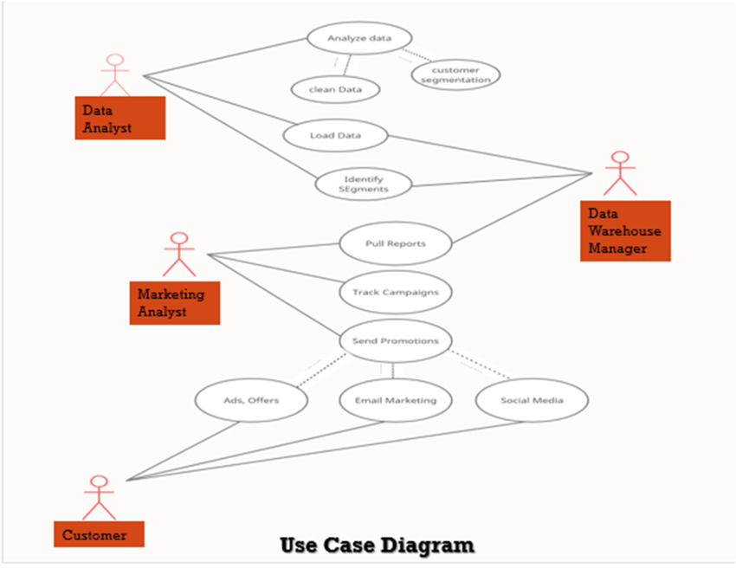

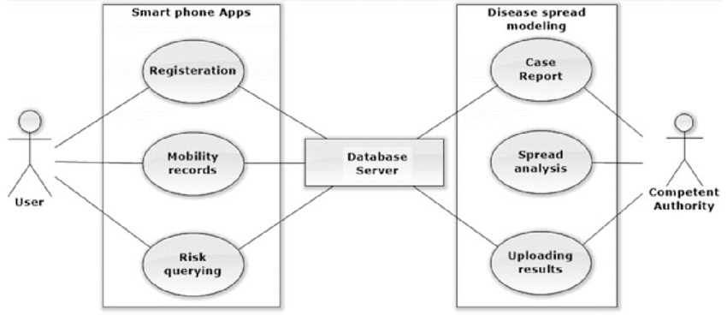
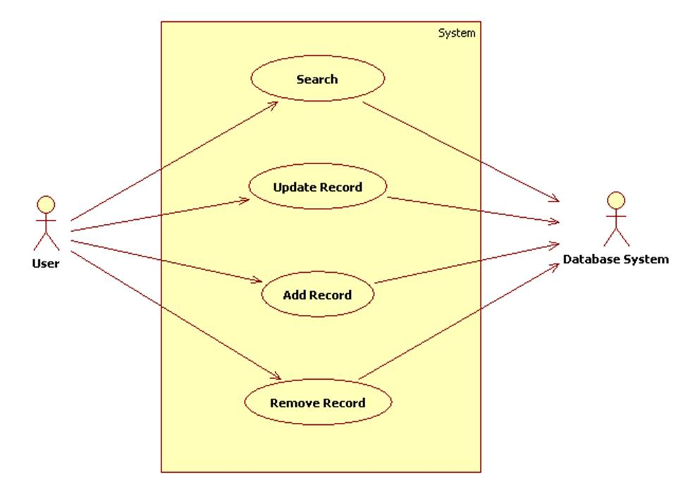
The Use Case Diagram represents the interaction between the user and the system. In this project, the main actor is the user who interacts with the system to perform actions such as uploading data, executing SQL queries, and viewing analysis results. The system processes these requests and provides outputs in the form of tables and visualizations. This diagram helps in understanding what functionalities the system provides and how the user utilizes them.
Class Diagram
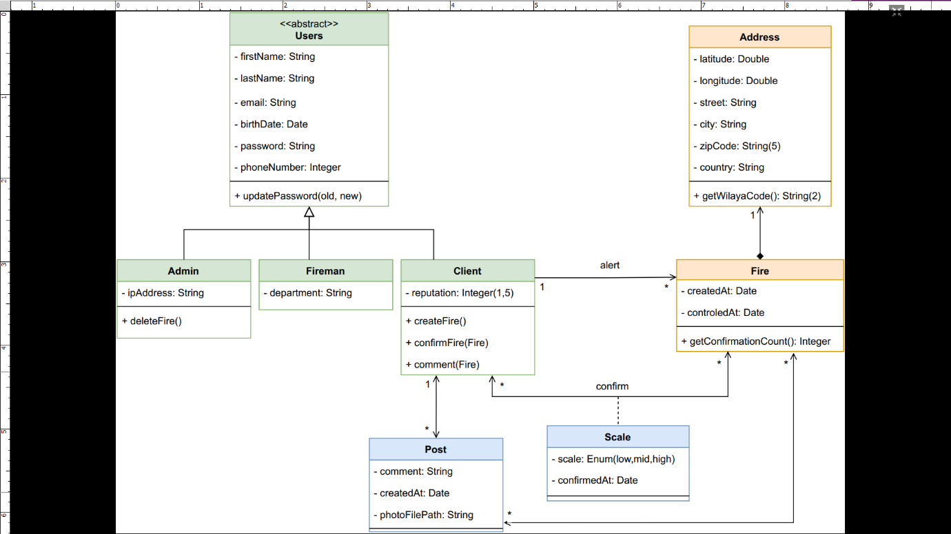

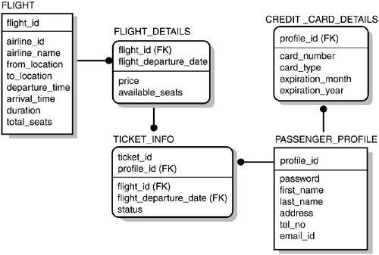
The Class Diagram shows the structure of the system in terms of classes and their attributes. In this project, the main class represents the airline ticket dataset, which includes attributes such as airline name, source, destination, distance, travel class, days left for departure, and ticket price. Additional derived attributes such as route and price category may also be included. This diagram helps in understanding how data is organized and how different attributes are related within the system.
Sequence Diagram
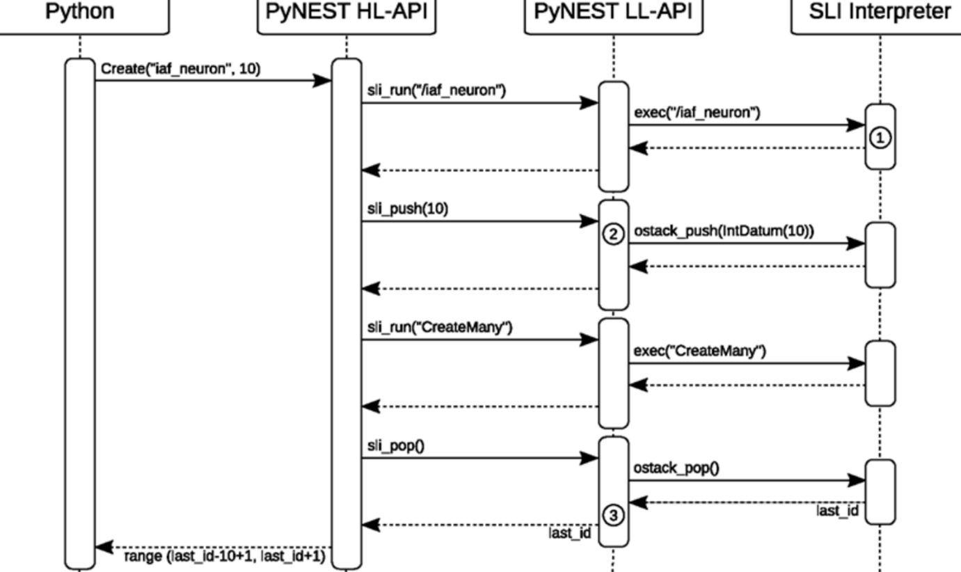
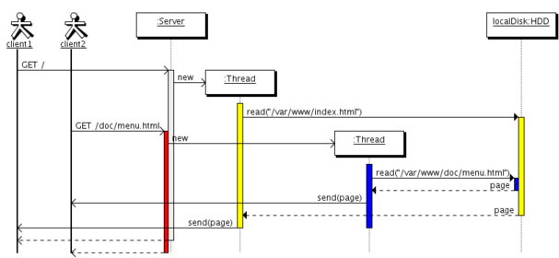
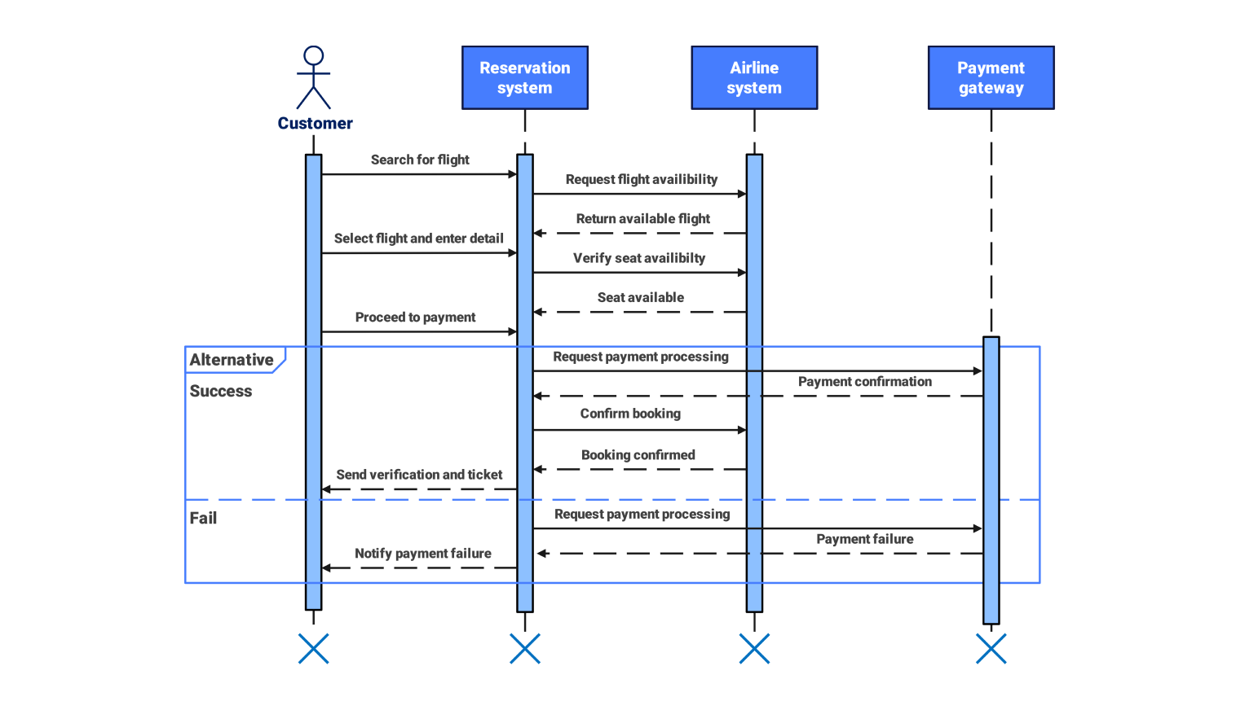
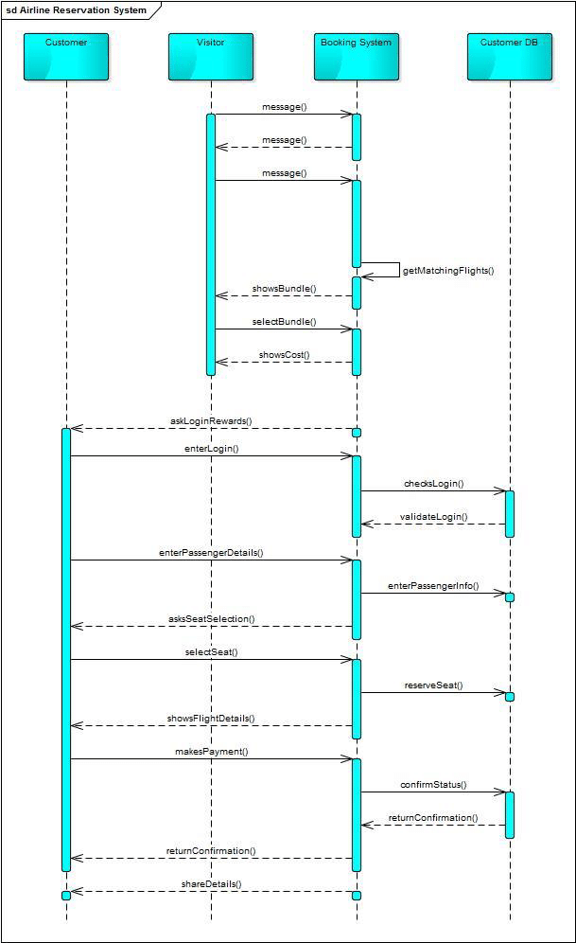
The Sequence Diagram illustrates the step-by-step interaction between different components of the system over time. It shows how the user sends a request, how the system processes it using SQL queries, and how the data is passed to Python for further analysis. Finally, the results are generated and displayed to the user. This diagram helps in understanding the flow of operations and the order in which tasks are executed within the system.
Overall, these UML diagrams provide a clear and simple representation of the system’s functionality, structure, and workflow, making it easier to understand the design and operation of the data analytics application.

Outputs
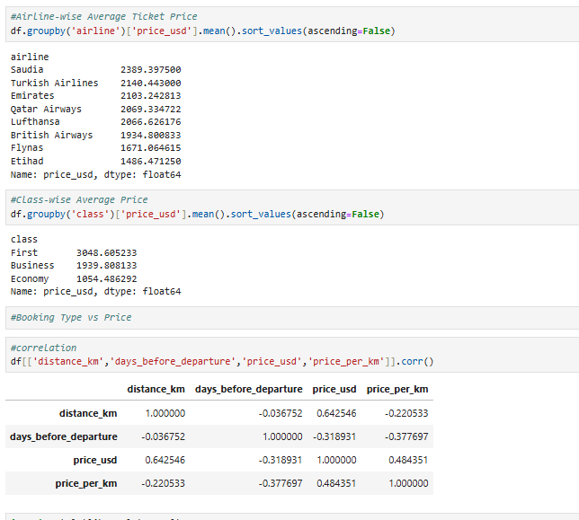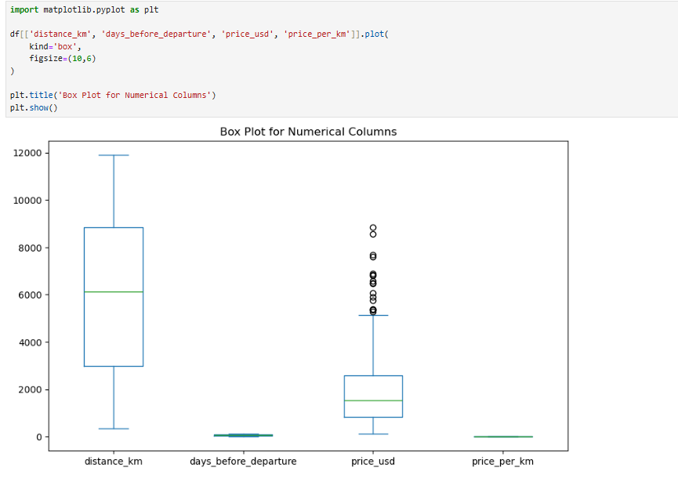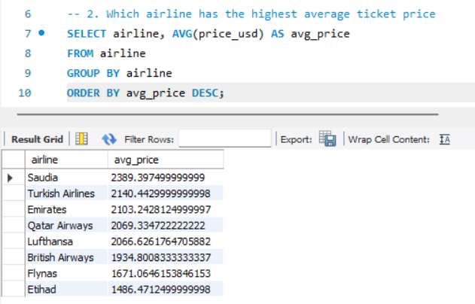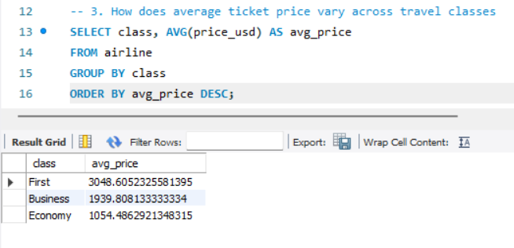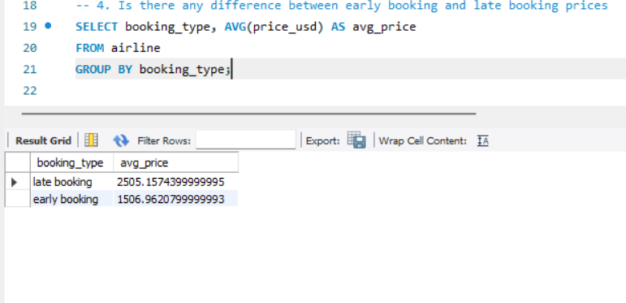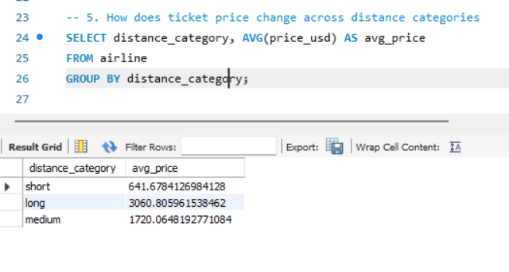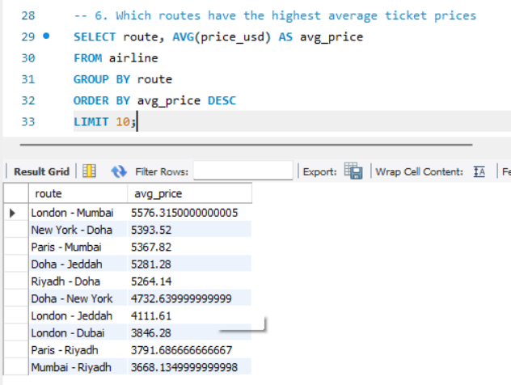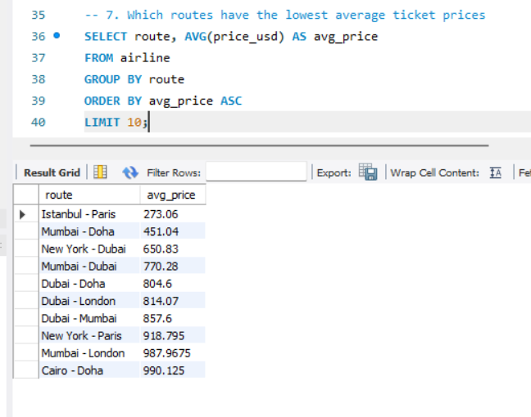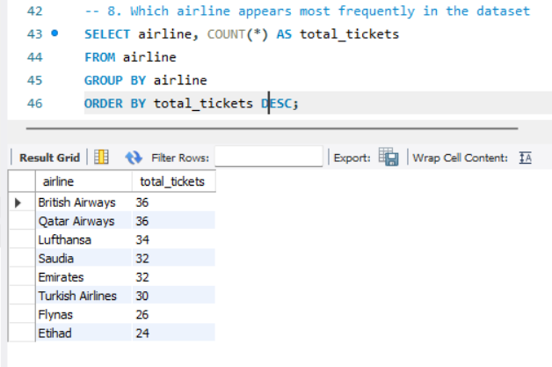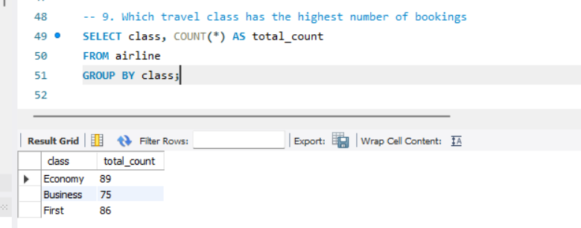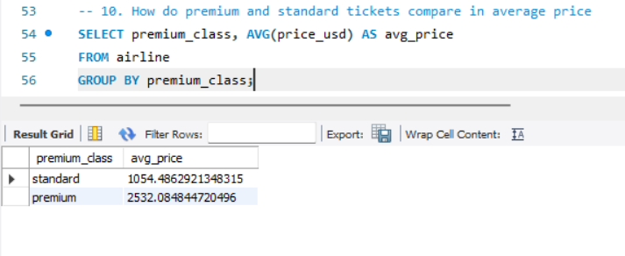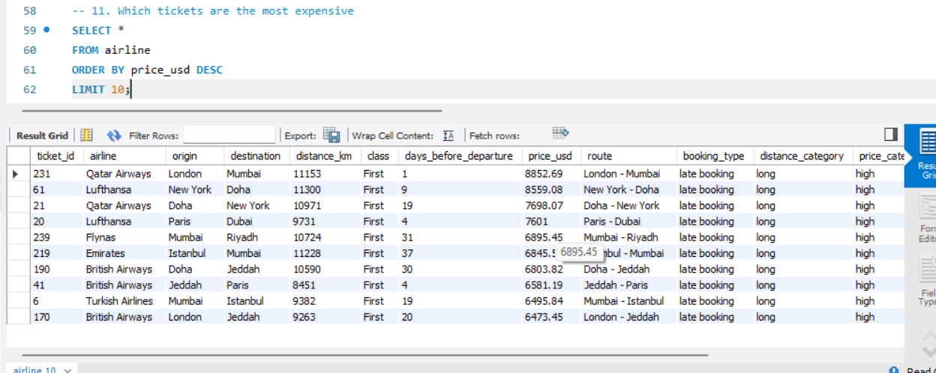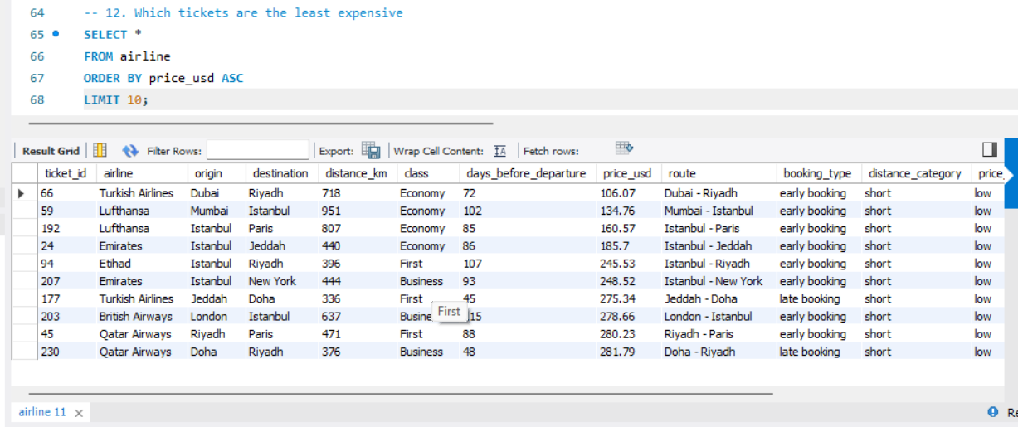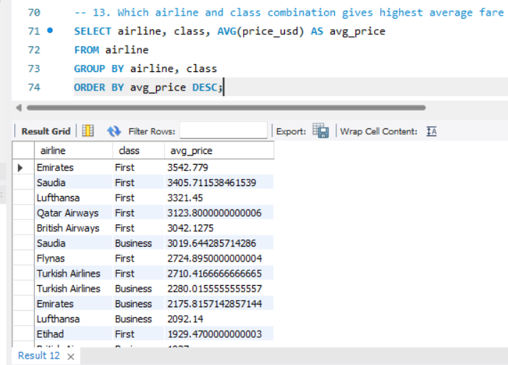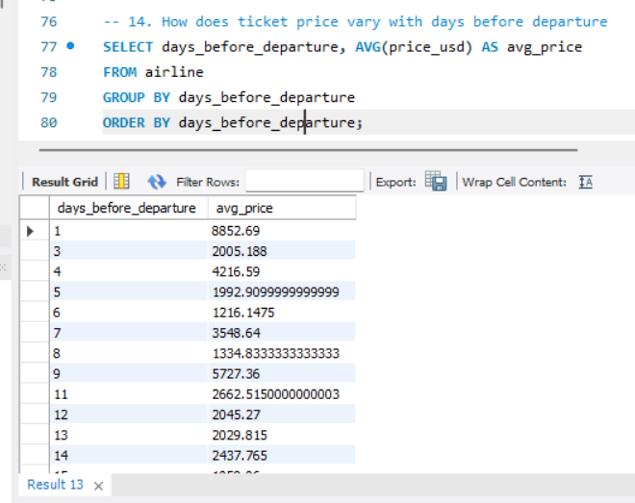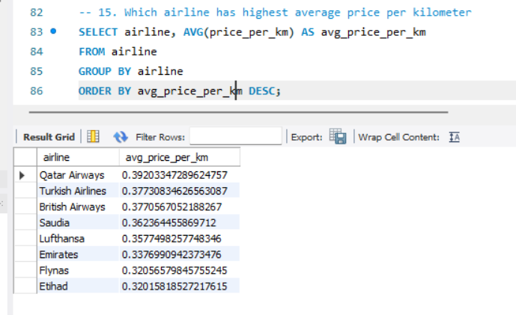
14. OUTPUT AND ANALYSIS
This section focuses on analyzing the results obtained from SQL queries and interpreting the outputs in the form of tables. Each query helps in understanding specific aspects of airline ticket pricing, and the results are examined to identify patterns and derive meaningful insights. The outputs referenced in this section are based on the generated result tables and observations from the analysis files .
The first set of outputs focuses on airline-wise price comparison. The SQL query groups the data by airline name and calculates the average ticket price for each airline. The result table shows variation in pricing across different airlines. A clear pattern observed is that some airlines consistently maintain higher average ticket prices compared to others. This indicates differences in service quality, brand value, or route coverage. The insight derived from this output is that airline choice significantly influences ticket pricing, and passengers may pay more for premium airline services.
The next output analyzes route-based pricing by grouping data using source and destination. The query calculates average ticket prices for each route combination. The result table shows that certain routes have significantly higher fares compared to others. This pattern suggests that route demand and popularity play an important role in determining ticket prices. Routes connecting major cities or high-traffic destinations tend to have higher pricing. The insight here is that route selection directly impacts airfare, and choosing alternative routes may help reduce travel costs.
Another important output examines the impact of travel class on ticket pricing. The SQL query groups data based on travel class and computes average prices for each class. The results clearly show that premium classes such as business or first class have much higher ticket prices compared to economy class. The pattern is consistent across all records, indicating a strong relationship between service level and cost. The insight is that travel class is one of the most influential factors in airfare variation.
The analysis also includes booking time impact, where the SQL query groups records based on days left before departure. The result table shows that ticket prices are generally lower when bookings are made earlier and increase as the departure date approaches. This pattern confirms the common pricing strategy followed by airlines. The insight is that advance booking plays a crucial role in reducing travel costs, while last-minute bookings are usually more expensive.
Distance-based analysis is another key output, where the query groups data by distance ranges and calculates average ticket prices. The results show a clear trend where longer distances are associated with higher ticket prices. However, the increase is not always proportional, as some long-distance routes may have competitive pricing. The insight is that distance is a major factor influencing ticket price, but other variables such as demand and airline also contribute to final pricing.
Additional observations from the dataset further support these findings. The presence of high-value outliers in ticket prices indicates that certain flights, especially premium class and long-distance routes, are priced significantly higher than average. Correlation analysis shows that distance has a strong positive relationship with ticket price, while days before departure has a negative relationship, confirming that earlier bookings lead to lower fares. These observations reinforce the patterns identified through SQL query outputs.
Overall, the output and analysis section demonstrates how structured SQL queries and result tables help in understanding airline ticket pricing. By examining patterns across airlines, routes, travel classes, booking time, and distance, the analysis provides clear insights into the factors that influence airfare and explains real-world pricing behavior in a systematic manner.

15. CONCLUSION
The airline ticket price analysis successfully achieved its objective of understanding how different factors influence airfare. By using structured data stored in a MySQL database and applying SQL queries along with Python-based processing, the project was able to identify clear relationships between variables such as airline name, route, distance, travel class, booking time, and ticket price. The analysis provided a detailed view of how pricing varies across different travel conditions and helped in explaining the reasons behind fare differences observed in real-world scenarios.
One of the key learnings from this project is that airline ticket pricing is influenced by multiple factors working together rather than a single variable. Distance was found to have a strong impact on ticket price, with longer routes generally costing more. Booking time also played an important role, where early bookings resulted in lower prices and last-minute bookings were more expensive. Travel class showed a consistent difference in pricing, with premium classes having significantly higher fares compared to economy class. Additionally, variations across airlines and routes highlighted the importance of demand, competition, and service level in determining ticket prices.
The project also demonstrated the effectiveness of combining SQL and Python for data analytics. SQL provided efficient data storage and fast query-based analysis, while Python enabled data cleaning, transformation, and visualization. This combination ensured accurate results and made it easier to identify trends and patterns in the dataset. It also showed how structured analytical approaches can simplify complex real-world problems.
The benefits of this analysis are significant for both users and decision-makers. For passengers, the insights help in making informed decisions such as choosing the right booking time, selecting cost-effective routes, and understanding price differences between travel classes. For organizations, the analysis provides a better understanding of pricing strategies and market behavior, which can support planning and optimization. Overall, the project highlights how data analytics can be effectively used to study airline ticket pricing and generate meaningful insights that are useful in practical situations.

